|  |
| --- |
| **Faculty of Computer & Information Sciences Date: / 11/ 2016**  **Course title: Geographical Information Systems Time: 3 hours**  **Department of : Information Systems Semester: 2nd term , May 2016**  **4th Year Total Marks: 100 M Number of Pages: 4 pages** |

**Q1) *Compare between both of : ( 20 Marks)***

1. Spatial data and Descriptive data .
2. Raster data and Vector data .
3. Head-Up digitizing and Digitizing Table.
4. Point mode and Streaming mode.
5. Thematic Layer and Coverage
6. Dangle node , True node & Pseudo node.
7. GIS & Remote Sensing.
8. Buffer and Dissolve
9. Connectivity and Contiguity.
10. Overlay and Network Analysis.

***Q2) True or False - Correct the wrong answer ( 8 Marks)***

1. A shape file is a folder containing feature classes .
2. GPS instrument is used to get the control points coordinates in meters.
3. You can group points and lines into the same feature class.
4. Vector is faster but the raster is corrector
5. In the geodatabase data format, spatial features and their attributes are stored in the same RDBMS.
6. ArcGIS offers efficient data entry methods for automating paper maps and other no digital data sources.
7. Pseudo nodes are located between two arcs linked together.
8. Conic projections are often used to produce the maps found in atlases and for maps that represent the entire earth.
9. Point mode is useful for curved line .
10. Spatial resolution is the dimensions of each cell in a raster data set.

**Q3) *Write down in details about the : (12 Marks)***

1. What is topology? Give an example of vector topology ?
2. Mention the four functions which GIS must include.
3. List six points of comparison between the Raster and Vector Data Model.

Q4 . The map of roads below shows seven numbered nodes (the circled numbers), and six numbered arcs.

1. **Use the table to list the from-node and the to-node of each arc (1 point)**. This table expresses ***directionality***.

|  |  |  |
| --- | --- | --- |
| **Arc** | **From Node** | **To**  **Node** |
| **1** |  |  |
| **2** |  |  |
| **3** |  |  |
| **4** |  |  |
| **5** |  |  |
| **6** |  |  |

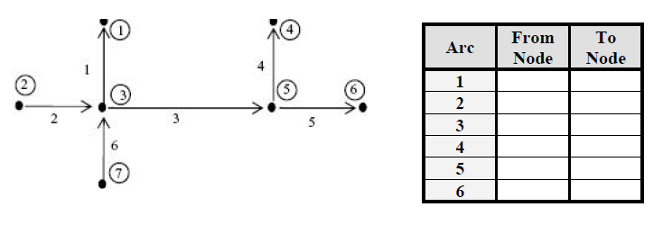

Note that one or more arcs can share a node; but by definition, a node cannot exist without an arc. In the table below, list the arcs you would traverse to get from node 6 to node 1 (in the figure above). Also, indicate your direction of travel across each arc (i.e., beginning at the from-node and traveling to the to-node, or vice versa). This demonstrates arc ***connectivity***.

1. **List the path from Node 6 to Node 1 in the table below:**

|  |  |  |  |  |  |
| --- | --- | --- | --- | --- | --- |
| **Arc #** | **5** |  |  |  |  |
| **Direction** | **-** |  |  |  |  |

‘+’ = from-node to to-node

‘–’ = to-node to from-node

1. **Arcs connect if they share a _____________________?**

The next part of this Question illustrates **polygon-arc topology** which expresses the relationship between arc features and the polygon features for which arcs create boundaries. It defines **area** and **adjacency** (**contiguity**) of polygons. Using the first table below, define each polygon (indicated by circled numbers) in the figure below by listing the arcs (i.e. lines) that connect to create it. Record the number of each arc in the table. Then in the second table (on the next page), for each arc, list the polygons to the left and right sides. Note: arrows indicate the direction of the arcs. This demonstrates polygon **adjacency**.

*Note: Always start with the lowest numeric valued arc and continue in a clockwise direction.*

|  |  |  |
| --- | --- | --- |
| **Polygon** | **No. of Arcs** | **List of Arcs** |
| **1** | **0** | **0** |
| **2** |  |  |
| **3** |  |  |
| **4** |  |  |

1. **Using the table below, define each polygon (circled numbers in figure) by listing the arcs that connect to create it. Record the number of each arc in the table**

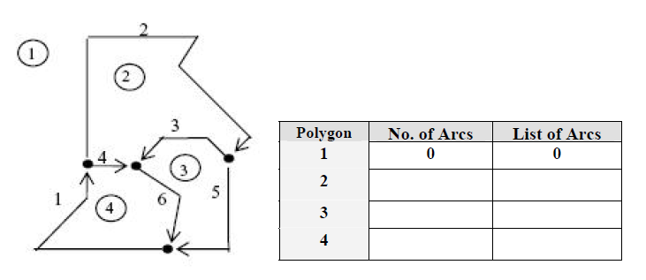

*Note, the direction of the arc determines which arc is identified as the” left” and which is the” right” polygon. Think of direction as if you are driving down a one way street (that is the direction of the line). When you look out the driver’s window, you are looking at the left polygon and when you look out the passenger’s side window, you are looking at the right polygon.*

1. **From the above figure, for each arc, list the polygons to the left and right sides (in the table below). Note, arrows indicate the direction of the arcs. (1 point)**

|  |  |  |
| --- | --- | --- |
| **Arc** | **Left Polygon** | **Right Polygon** |
| **1** |  |  |
| **2** |  |  |
| **3** |  |  |
| **4** |  |  |
| **5** |  |  |
| **6** |  |  |

**6. How many arcs are in the figure below?**



Now I have added an intersecting arc.



1. **How many arcs are in this new figure above?**

**2) According to the next figures, Identify digitizing errors , and how to correct its if possible** ?

(**5 Marks**)

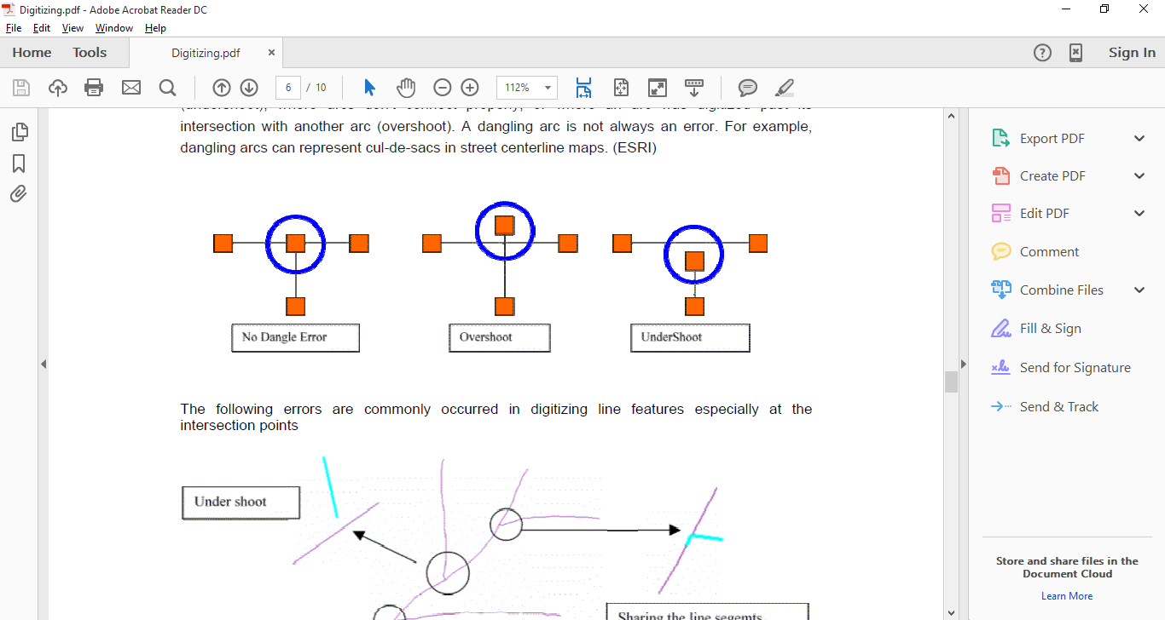  

……………… …………… ..…………

**__________________________________________________________________________**

**With My Best wishes**

**Dr. Ahmed . A . Elfotouh**